Alberta Oil Sands
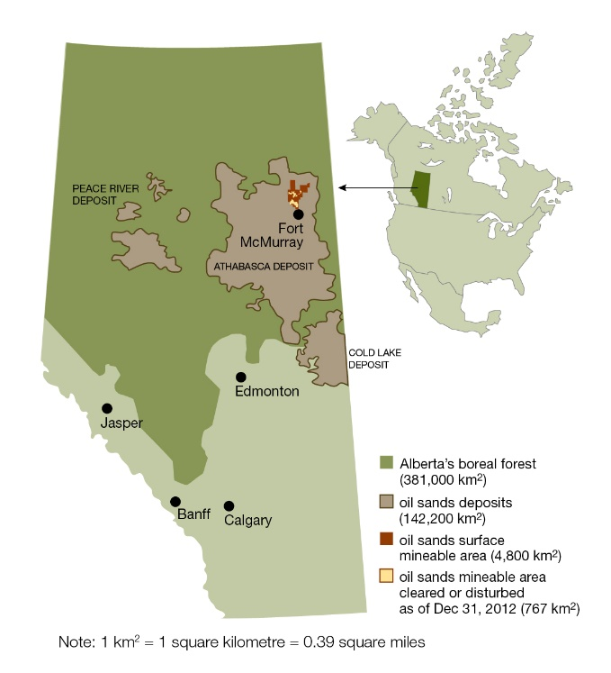

The Alberta oil sands (also known as the Athabasca oil sands or Athabasca tar sands) are large deposits of bitumen (extremely heavy crude oil) located in the northeastern area of Alberta. These oil sands consist of a mixture of crude bitumen, silica, sand, clay minerals, and water, with the bitumen in the form of a semi-solid rock of crude oil. This area is the largest known reservoir of crude bitumen in the world, containing approximately 1.7 trillion barrels.
The oil sands lie beneath a 141, 000 square kilometer of boreal forest and muskeg (peat moss).
Two extraction methods are used to obtain this bitumen, with both having different positive and negative impacts on the environment:

Fig 1

In Situ Extraction
Utilized when the bitumen occurs deeper within the ground, which accounts for 80% of the harvestable bitumen in the oil sands
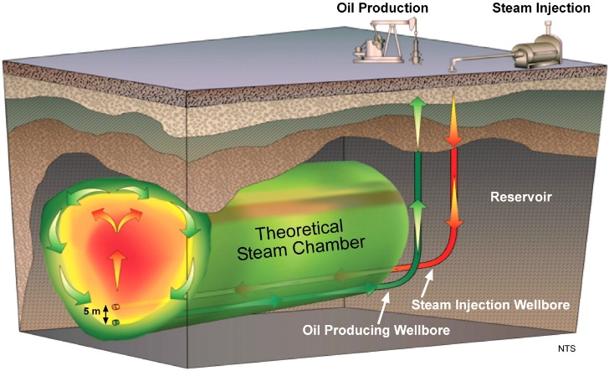
Utilizes a steam-assisted gravity drainage (SAGD) to extract the bitumen

Surface / Open Pit Mining
Used when the bitumen is located close to the surface, which accounts for only 20% of the harvestable bitumen.
Characterized by large scale excavation of the land with huge hydraulic power shovels and 400-ton heavy hauler trucks.
This method leaves behind toxic tailings ponds.

Fig 2
The oil first began being harvested by the Great Canadian Oil Sands plant in 1967, in Fort McMurray. The plant cost $240 million (USD) to create, with a capacity of producing 45,000 barrels per day (bpd).
The Alberta oil sands have many critics, because of the number of environmental impacts that are created by the mining process (despite the government attempting to reduce the environmental and health risks associated with large-scale mining operations). Some areas that are seeing impact from the large-scale mining operation are the land and water, the air from natural gas use, animals, and tailing ponds.

