Pun and Visual Pun!

Fill in the Blanks for our Helpful Definitions! (If you’re having trouble coming up with answers, try using google to define them)
Pun:

Visual Pun:

Paper Mache:

Texture:

Shape:

Colour:

Assignment Description:
For this assignment you will be required to create a 3D Paper Mache sculpture that clearly demonstrates a visual pun. Your sculpture can be:
- Humorous
- Metaphorical (one thing shown as representing another; a symbol, a figure of speech where a word or phrase that ordinarily means one thing is used to mean something else, which makes a comparison, as in "a sea of troubles")
- A visual oxymoron (two images that are put together, that don’t make sense being placed together -a lead balloon, clear as mud)
- A Parody (artistic work that imitates the style of an author or a work for comic effect or ridicule, intentional mockery)

Examples!
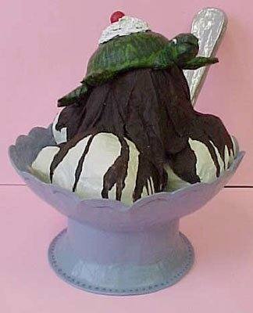
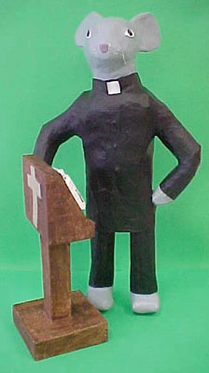
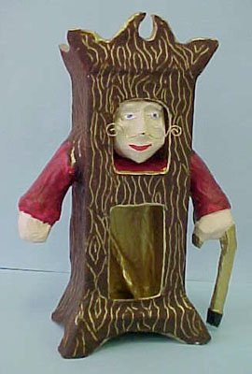

Grandfather Clock Church Mouse Turtle Sundae
Assignments:
- Assignment #1 Thumbnail Sketches: Take 3 of these ideas of what you might do for your assignment and create a thumbnail sketch of each. DUE: START of class Wednesday April 3rd

- Assignment #2 Final Sketch: Take the design that works best and elaborate on it. Draw it to exact proportion with detail included. DUE: Friday April 5th

- Create a 3D Paper Mache Sculpture based on the design you liked best. DUE: Wednesday April 24th

