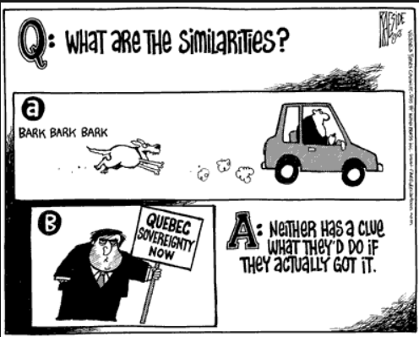
Political
Cartoon #1

(Sovereignty: the right of a governing body to fully govern and control itself, without any other political force interfering or trying for control)
http://debateqc.weebly.com/uploads/1/5/4/8/15489124/5552883.jpg?652
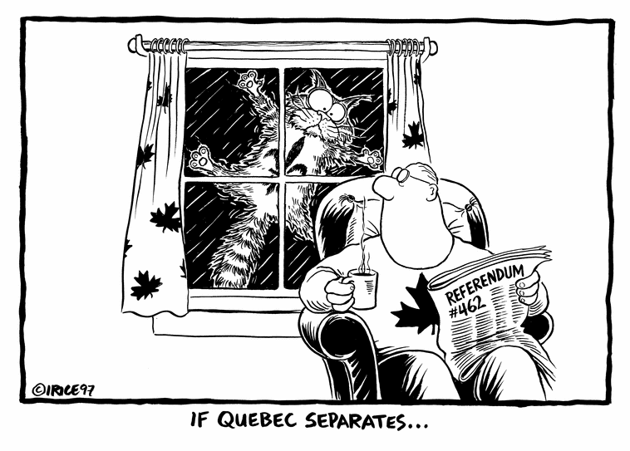

Political Cartoon #2

http://www.thinglink.com/scene/457557544915697666

