Historical Marker
Directions: Which event do you think is the most important event in that we’ve studied about Canada’s history? You are going to be creating a marker that will tell tourists about the significance of that event.
- Choose your event and write what it in the CIRCLE on the top of the historical marker.
- Next, write a short description of the event.
- Then, write a brief opinion statement on why you think that this event is important.
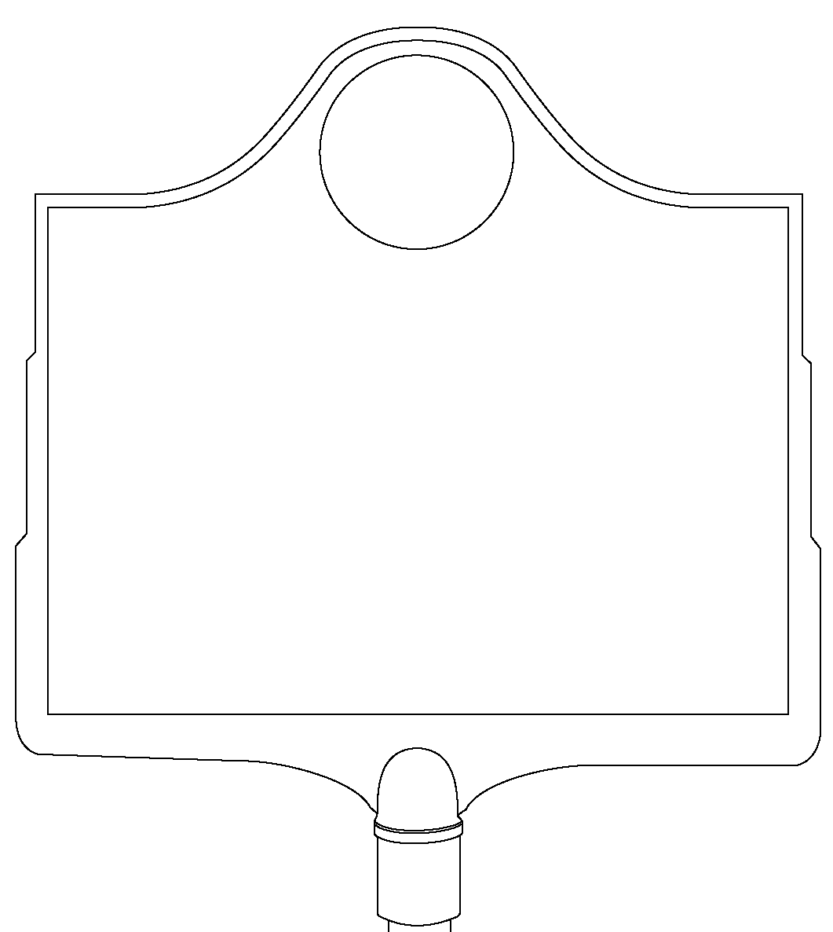
- At the bottom, write the place where your marker will be located.
- Draw an illustration that symbolizes your event.
- Color your historical marker. Please do not leave any white space.
- Cut your marker out and turn it in.

